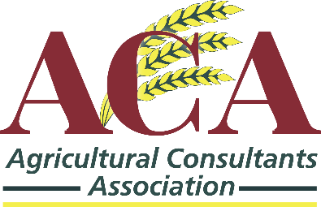

PRESS RELEASE

ACA welcomes Minister McConalogue’s historic announcement of support for training of agricultural consultants

17th October 2020

ACA President, Tom Canning stated this morning ‘The announcement today of support for training of agricultural consultants is an historic and significant day for our members and the entire sector including our farmer clients’. He added ‘as the largest provider of farm advice in Ireland, we welcome this first ever commitment to the private sector to assist and develop the necessary skills for the new challenges in our sector as the advisory service will play a significant role in behavioural changes of Irish farmers in areas such as climate action and farm safety’.

Canning said ‘I want to sincerely thank Minister Charlie McConalogue and his senior DAFM officials for engaging with us on this important matter and understanding the tremendous positive impact such a programme will have on the sector. The support of Minister’s Heydon and Hackett and from Department officials across all sections of the DAFM for our proposal is also greatly appreciated’.

According to Canning ‘we are entering very challenging times for Irish farmers and ACA members will, as always, work closely with the DAFM in contributing to enhance the provision of advisory services to Irish farmers. This announcement today acknowledges the critical role of agricultural consultants and we believe this development is the commencement of full and greater collaboration between all the stakeholders in the advisory service’.

In conclusion, Canning stated ‘ACA welcome all of the other positive announcements in the recent budget and thank all DAFM Ministers and their officials for considering our recommendations and key targets in the transition period from 2021 until the next CAP. These new initiatives and supports will create a positive impact for farmers and the sector at such a critical time’.

ENDS

------------------------------------------------------------------------------------------------------------------------

For further information contact: Mr. Breian Carroll,
General Secretary, ACA
Contact details: 087 2695425

or ACA Secretariats Office,
Carrick on Suir,
Co. Tipperary
Contact details 051645705

Note to Editors:

The Agricultural Consultants Association (ACA) are the sole representative body for private agricultural consultants and advisors in Ireland. Currently the ACA have 166 member offices across all of Ireland and employ 272 Agricultural and Environmental graduates, 17 Forestry Consultants and 120 employed as either administration or technical staff. Members of ACA advise in the region of 55,000 Irish farmers, confirming the private advisory service as the largest in Ireland.

New Vision and Mission Statement of ACA

- Our vision is to be the most influential and dynamic Agri-business association consulted nationally and internationally and recognised for its excellence in representing the world-class independent professional Agri-business advisors in Ireland

2. The Mission statement: to bring our Vision into reality the Association represents and supports its members and is the professional body consulted on policy by government. The Association ensures that standards of excellence are maintained among the members through its code of ethics, admission qualifications and continuous professional education. This allows members to independently advise and assist the Irish farming community to be profitably sustainable economically, environmentally and socially to ensure an enhanced quality of life for all in Ireland.

